

Michael hazel

BeStill Corporation

2/19/2020

United Kingdom Identity Card

Project Closure Document

Table of Contents

Introduction …………………………………………………………………………………….. 3

Verification Plan

Verification Plan – Feedback ………………………………………………………………….. 4

Verification Plan – Criteria …………………………………………………………………… 4

Verification Plan – Test Cases …………………………………………………………………. 5

Project Closure

Postmortem Summary – Methodologies ……………………………………………………….. 6

Postmortem Summary – Method Evaluation …………………………………………………… 7

Postmortem Summary – Risk Mitigation ………………………………………………………. 8

Project Status

Project Status – Objectives …………………………………………………………………….. 11

Project Status - Issues ………………………………………………………………………….. 13

Project Status – Alternatives / Recommendations …………………………………………….. 14

Project Status - Communications ……………………………………………………………… 14

Project Closure

Project Closure – Future Enhancements ………………………………………………………. 15

Project Closure – Implementation Support ……………………………………………………. 15

Project Closure – Maintenance Plan …………………………………………………………... 16

Appendix

Work Breakdown Structure (WBS) …………………………………………………………… 17

Gantt Charts …………………………………………………………………………………… 18

High Level Network Diagram ………………………………………………………………… 22

Network Connection Diagram ………………………………………………………………… 23

Switch and Router Connection Diagram ……………………………………………………… 23

Multi-location Network Configuration ………………………………………………………... 24

Project References and Resources …………………………………………………………….. 25

**Introduction**

The United Kingdom is seeking “a convenient method for individuals to prove their identities and to provide a secure and reliable means of identifying individuals” (Beynon-Davies, 2011) that would be a universal tool in the battle against terrorism, controlling immigration, controlling illegal working practices and to assist in combating identity fraud. Currently, there are numerous individual identification programs in place within the United Kingdom such as the current identification services, driver’s license bureaus, passport services, vital records information, credit bureaus and other civil service branches. Each of these individual agencies maintain their own separate databases of personal data concerning their customers, clients and citizens. The problem is currently there is no single viable network in place to collect, verify and process the individual identification data within the United Kingdom.

The creation and implementation of proper verification checkpoints, each utilizing the most current and up-to-date network equipment, state of the art security, secured databases to store pertinent data and a secure method of encrypted transmission of data to a new central database would begin the process of obtaining positive and verifiable identification for UK citizens. The creation of this country wide network of checkpoints and registration centers, each connected to the National Identity Register, would allow the United Kingdom to move forward with their demands of a national identification program.

This project will outline the main modules, components, security measures, card scanners, card readers, security protocols, hardware, software, networking requirements, support equipment, database requirements and other necessities that would be crucial for the efficient and functional operation of a registration location or identification checkpoint within the United Kingdom.

**Verification Plan**

In this system verification plan for the United Kingdom Identity Card project, we will be examining all aspects of the project to ensure that it is secure, functioning and within the project guidelines and parameters. The verification process “confirms that a system element meets design-to or build-to specifications” (AcqNotes, 2017).  “Throughout the systems life cycle, all levels of the physical architecture are verified through a cost-effective combination of analysis, examination, demonstration and testing” (AcqNotes, 2017).

**Verification Plan - Feedback**

Project feedback from all sources throughout the lifecycle of this project is crucial and has the potential to change the direction of the project in order to efficiently and effectively lead the project to a successful completion. This project feedback will be collected through biweekly meetings with the shareholders, project manager, team leads and other key project members. Feedback from contractors, installers, inventory specialists, programmers and system technicians will also be collected and discussed within these meetings. Feedback will also be derived from status reports, email updates or requests, field test results, risk analysis and projected growth reports.

**Verification Plan - Criteria**

The collection of feedback from all sources will be analyzed by the project manager and the relevance of all feedback will be determined by testing the alignment of such feedback against the project deliverables.  If relevant, then the project manager will ascertain whether it will be a feasible or necessary project addition to be implemented. If determined to be of benefit to the project, an additional meeting shall be called with the stakeholders to discuss implementation, costs and effects to the timeline and budget. Project revisions cannot move forward without stakeholder involvement and approval.

**Verification Plan - Test Cases**

The proper operation of this project is dependent on the ability to perform the objectives set forth in the project proposal. This project is aimed at providing registration facilities and identity verification checkpoints at key locations throughout the United Kingdom. These locations must operate as defined by collecting citizen data through registration, access the National Identity Register for verification and must preserve the confidentiality, integrity and availability of all data collected. Specific test cases must be performed to ensure the system is fulfilling all objectives of the project. The testing and verification of the project parameters will consist of the following steps which will be evaluated and modified as the project progresses.

* Network testing to ensure all components are properly connected and networked through the use of virtual private networks (VPNs) and/or generic routing encapsulation (GRE).
* Additional security protocols will be in place for all databases, hardware components, printers, scanners, ID scanners, copier/fax machines, webcams, and other equipment that may be connected to the network.
* All firewalls are properly functioning by blocking all non-secure, unwanted or questionable network traffic. This will be tested by an outside agency specializing in system security.
* Testing to ensure security software and protocols are in place and properly protecting the network. Security protocols will be internally installed and tested. Additional testing will be accomplished by utilizing an outside organization to attempt to infiltrate and bypass installed system security and firewalls.
* Verifying all local components are properly networked to ensure seamless inter-office operation.
* Verifying all system software current and is performing as required.

Verifying the DBMS is properly manipulating user data within the databases and the correct data is being retrieved as requested. Verification that the correct data is being populated and properly stored across all databases. This will be accomplished by running a series of data check verification tests with local databases and the main NIR database.

**Project Closure**

**Postmortem Summary: Methodologies**

At the onset of this project, the management team decided that an Agile methodology approach would be the most suitable method to ensure project success. The Agile methodology is “used to deliver complex projects due to its adaptiveness. It emphasizes collaboration, flexibility, continuous improvement and high-quality results” (Muslihat, 2018). The most significant benefit of the Agile methodology is the flexibility. As this project progressed through its life cycle, it was updated in order to meet parameter adjustments, deliverable changes and to maximize resources. This methodology allowed for the flexibility of these project adjustments without having to relaunch the project from the point of initiation. This project, as a whole, was minimalized into a collection of multiple different projects, or sprints, which are iterations of the different phases of the project itself. “By producing frequent builds and conducting testing and reviews during each iteration, quality is improved by finding and fixing defects quickly and identifying expectation mismatches early” (Seque, 2015). This type of flexibility was crucial as each phase began to populate the necessary data as outlined within the problem statements.

**Postmortem Summary: Method Evaluation**

During the very beginning stages of this project, adequate research time was allotted to each of the major methodologies that are currently being utilized in the project management field. We researched each of the most popular management methodologies in order to find the correct methodology to manage our project. Each of these methodologies; Agile, Scrum, Kanban, Scrumban, Lean, eXtreme Programming (XP), Waterfall, Prince2 and PMI PMBOK had their strong points as well as weaknesses. At the end of our research, we decided to use the Agile project management process because it “ is different from other project management methods which usually assume that things affecting the project are predictable, and so it emphasizes adaptability to changing situations, adequate and ongoing communication among the project team and between them and the client” (Benaston, 2019).

Proper documentation of project deliverables, parameters, mapping, network diagrams and most connection diagrams will be developed through the use of Microsoft Visio, Microsoft Access, Microsoft Project and Microsoft Word. These tools allowed for the creation of all required project documentations called for within the project parameter documentation.

Some aspects of the project such as network and connection testing, VPN connection verifications, database security testing and data collection verification methods, could not be documented or verified due to limitations and restrictions beyond managements controls. However, these parameters would need to be mapped, tested, verified and all issues resolved using current equipment, software and protocols.

**Postmortem Summary: Risk Mitigation**

The potential risks associated with this project included various aspects such as data collection and storage issues, data security concerns, implementation costs, budget constraints, equipment and component acquisition costs, time constraints, citizen participation, policy enforcement and scalability concerns. Throughout the project life cycle, there were specific risks that required mitigation in order to move the project forward. Some of these risks will be discussed hereafter.

* Data collection / storage risks -Data collection errors are inherent to any system in which data must be entered into any type of database. Data verification measures such as a double-entry method or a proofreading method could be utilized. The double-entry method requires the data to be entered a second time in order to verify the data and is a preferred method of verification. The proof-reading method requires that someone verifies all data before it is processed for the next step in the process. This method is not a preferred method for this project due to the added manpower required. Both methods will check for accuracies and inconsistencies during data migration. All client documentation must be properly verified and scanned into the appropriate file for future verification and security measures.
* Data security – The risks for data to be lost, stolen or manipulated are always high and all measures must be taken to ensure data security at all times. This risk can be mitigated by utilizing proper security measures at the point of data acquisition. All data collection must be done utilizing the proper protocols and only on secured network devices. Data transmissions should utilize trusted, verified VPNs to ensure the data is kept safe during transmission to the main National Identity database.
* Implementation costs – Cost overruns are an ever-present risk of any project and it is vitally important to maintain strict control over costs throughout the project’s life cycle and implementation. In order to mitigate these cost overruns risks, ensure that departments and teams are operating within the scope of the project. An example of this risks was discovered within the research and development team where we were spending a considerable amount of time researching equipment and components that were beyond the scope of the current, revised scope and therefore were running the risk of operating outside of the budgetary restraints and quickly pushed the project budget beyond the actual resources allotted by the shareholders. These issues were mitigated by reviewing the new scope and refocusing on the new project parameters.
* Budget constraints – The proper management of all aspects of any project must maintain a watchful eye on the budget at all times. Any aspect of this national identity program could easily exceed any budgetary constraints if not constantly monitored. All requests for additional resources must be presented to the stakeholders for careful consideration and approval. Ensure the proper forecasting models are being utilized to maintain budgetary restraints.
* Acquisition costs – A moderate portion of this project budget is concentrated on the accurate acquisition costs of the required equipment, components and hardware required to develop and setup a functional network within any specified location. All aspects pertaining to the acquisition methods should have been outlined within the budgetary and stakeholder meetings. The proper management of all these costs must be verified and maintained through purchase orders and contracts to ensure the budget constraints are adhered to.
* Time constraints – Every aspect of this, or any project, has been proposed within a timeline that must be adhered to. These time constraints are put into place to ensure that the project is kept on track for a successful, on-time completion as laid out in the project proposal. It is recommended that an Agile methodology approach be utilized for any future expansions of this project due to the use of the iterations that allows each job, or sprint, to run almost independently and allows some specific tasks to be completed without a dependence of another separate task.
* Scalability – As this project develops and evolves into a nationwide institution, it is crucial that it is scalable and able to handle the increased data requirements for an efficient and effective operation well into its future life cycle. The use of a cloud-based database will allow for the required scalability within the grand scope of this project. The use of database servers will allow for the proper data protection at the local level during database maintenance or server downtime and data and then can be transmitted to the mainframe server to ensure the total security and confidentiality of all citizen personal information. The use of a third-party cloud server also reduces equipment and maintenance costs while offering recovery backups as well as safeguarding the confidentiality, integrity and accessibility of all data.
* System integration and compatibility – The discovery of issues involving the connectivity of certain hardware components was discovered during the implementation and testing phase of the project. This was found to be caused by a software incompatibility issue within the different software programming. This was mitigated by replacing effected hardware components with others operating compatible software. Further issues were mitigated by researching hardware system configurations and operating parameters before any specified purchases were made.

**Project Status**

This portion of the report will outline the status of all parameters of the project and will provide highlights of each objective.

**Project Status – Objectives**

The initial project objectives consisted of the design and construction of the network required for an individual registration location for the collection of individual personal data as outlined in the United Kingdom Identity Card scheme. The project scope was to determine the main modules, components, security measures, hardware, software and networking requirements necessary for the effective, efficient and functional operational of a registration location. Specifically, the project objectives were as follows:

Objective #1: The research, identification and sourcing of all pertinent equipment necessary to meet project specifications necessary for location configuration.

* Status: this objective was met through extensive market research of the leading networking, computers and identification verification systems currently available. These selections were based on function, features, security capabilities, scalability and costs.

Objective #2: Proper network connection configurations and operations are needed to ensure all components are configured according to enclosed network designs and diagrams.

* Status: this objective was accomplished through abiding by the complex network diagrams and mappings to ensure the correct system configuration was achieved. Network operation was verified through extensive testing performed by outside installation contractors.

Objective #3: Security measures and protocols must be active and current on all network devices and components that require an external connection to the internet. Additional security protocols must be instituted on all system databases.

* Status: this objective was achieved through verification of all security protocols installations and settings on each individual component requiring protection. Operation was verified by outside independent contractors as well as internal IT administrator.

Objective #4: Firewall protections must be installed on every incoming/outgoing network line in order to intercept and properly block all non-secure, unwanted and unsolicited network traffic. This is required in order to lessen or eliminate infiltration attempts of viruses, trojans, phishing scams, malware and other security intrusions designed to cause harm to the network.

* Status: Firewall installation and operations are currently in place and properly functioning. Broad testing of all switch ports was performed to challenge all security protocols and to ensure proper operation. The use of an independent contractor specializing in system breaching was employed to ensure no open switches or potential backdoors were present. Further in-house testing was performed by the system administrator to ensure total network protection.

Objective #5: Ensure that all system hardware drivers and software are the most current, up to date versions and are functioning as required by project guidelines.

* Status: This objective was successfully met through automatic driver updates and scheduled maintenance by the system administrator and appointed IT technicians.

Objective #6: All network traffic is required to be routed through virtual private networks (VPNs) and or generic routing encapsulation (GREs) to minimize or eliminate data corruption, loss or manipulation during data transmission.

* Status: This objective was successfully met during installation to ensure all traffic is routed as required and will continue to be monitored by the IT department staff to ensure compliance and to correct any issues immediately.

**Project Status: Issues**

A project of this magnitude entails a wide range of requirements to ensure that the project moves forward as dictated on the Gantt charts and timelines. Specific project issues were encountered early in the research stage which required a reevaluation of the entire project scope and direction. The initial project parameters had to be prioritized to enable a successful and on schedule program launch. This effectively redirected the project scope and realigned it into the new desired timeline, budget and time constraints.

Initially this proposal was to encompass the parameters and requirements of the entire United Kingdom nationwide network for citizen registrations. This colossal undertaking would not only include hundreds of existing checkpoints within major airports, train stations, ferry landings, ports of entries and private airstrips but would include the creation of hundreds of new border crossing identity checkpoints created by Brexit. A decision was made within a stakeholders meeting to create a model location that would serve as a design requirement for future expansions of registrations and identity verification checkpoints throughout the United Kingdom. The decision narrowed and modified the scope of the project which in turn created more reasonable and realistic project objectives. One that can be applied to future installations.

**Project Status: Alternatives / Recommendations**

An alternate method of data collection was proposed in the early stages of the project in order to reduce the amount of processing time and paperwork required for citizen registration. This proposal involved the use of pre-existing data already housed within existing national and civil databases within the United Kingdom government and civil offices. These databases are controlled by the Driver & Vehicle Licensing Agency, the Driver & Vehicle Standards Agency, the British Passport Service, the Department of Health & Social Care Agency and other smaller government and civil agencies. The use of this data would be a great asset that would drive down the costs in some areas of this project.

A recommendation of allowing all citizens to pre-register online through a government backed website prior to a scheduled appointment would ultimately reduce the time required during appointments by only having to verify data as compared to entering all data. The verification of physical documents could then be performed and entered into the network.

**Project Status: Communication**

Project status and recommendations have been successfully communicated to the management team and stakeholders throughout the life cycle of this project through bi-weekly status meetings to discuss the objectives, successes, failures, recommendations, future expansions and other pertinent details of the project. Additional communications have been successful through email updates, conference calls, video calls, and inter-office memos. Stakeholders and the management team may, at any time, request a meeting to discuss updates or other project aspects as well as request supporting documentation of any aspect, current or projected, of the project.

**Project Closure: Future Enhancements**

The main objective of this project was to provide a means for citizens to register for the new implementation of the United Kingdom Identity Card program which will serve as the basis for identity verification under the guidelines of the United Kingdom. Although this project creates a single verification and registration location, it is designed to be the model for all future verification location implementations. Future enhancements could be expanded to include all points of entry permissions, freedom of movement requirements or border crossing permissions. Modifications could be implemented for future use by law enforcement, border patrols, voter registration uses, jury duty requirements or any wide range of government or civil agencies. With the existence of the proposed secured network locations already connected to the National Identity Register – any number of legitimate applications required access to citizen data could potentially become an additional operational domain.

**Project Closure: Implementation Support**

The implementation of this project will consist of preparations and procedures to ensure a smooth transition from the planning stages into the live system that will be utilized by the general public. This implementation will begin with the stakeholder meetings to draft a conclusive agreement as to the roles of all staffing involved. These meetings will allow input from the stakeholders, team managers as well as other support personnel as to have the project will be supported.

The implementation will begin with the launch of a training program that will mimic the actual live system that will allow all current and future employees to be properly trained on how to operate within the new program. An educational website will be instituted prior to launch of the system for general public information as well as a social media campaign aimed at educating the general public on the purpose and the proper use of the new system, addressing any security concerns and giving people the opportunity to address any questions through the use of email communications.

**Project Closure: Maintenance Plan**

Specific members of the development and design team will transition over to become the maintenance support staff that will contend with the daily operational issues, deployment issues, compatibility problems, network issues, the isolation and correction of system issues that may affect the proper performance of the system network.

The local system will be analyzed on a predetermined schedule to ensure all hardware drivers, software, security software, system settings and other pertinent system requirements are operating as required according to the project parameters. Stakeholders will transition into an advisory capacity while still being consulted on any issues, expansions or upgrade suggestions, budgeting requests or other issues which require stakeholder involvement.

**Project Closure: Appendix**

Attached below are the project documentations that were utilized during the design, implementation and launch. The Gantt charts, timelines, networking diagrams and work breakdown structures are attached as well.

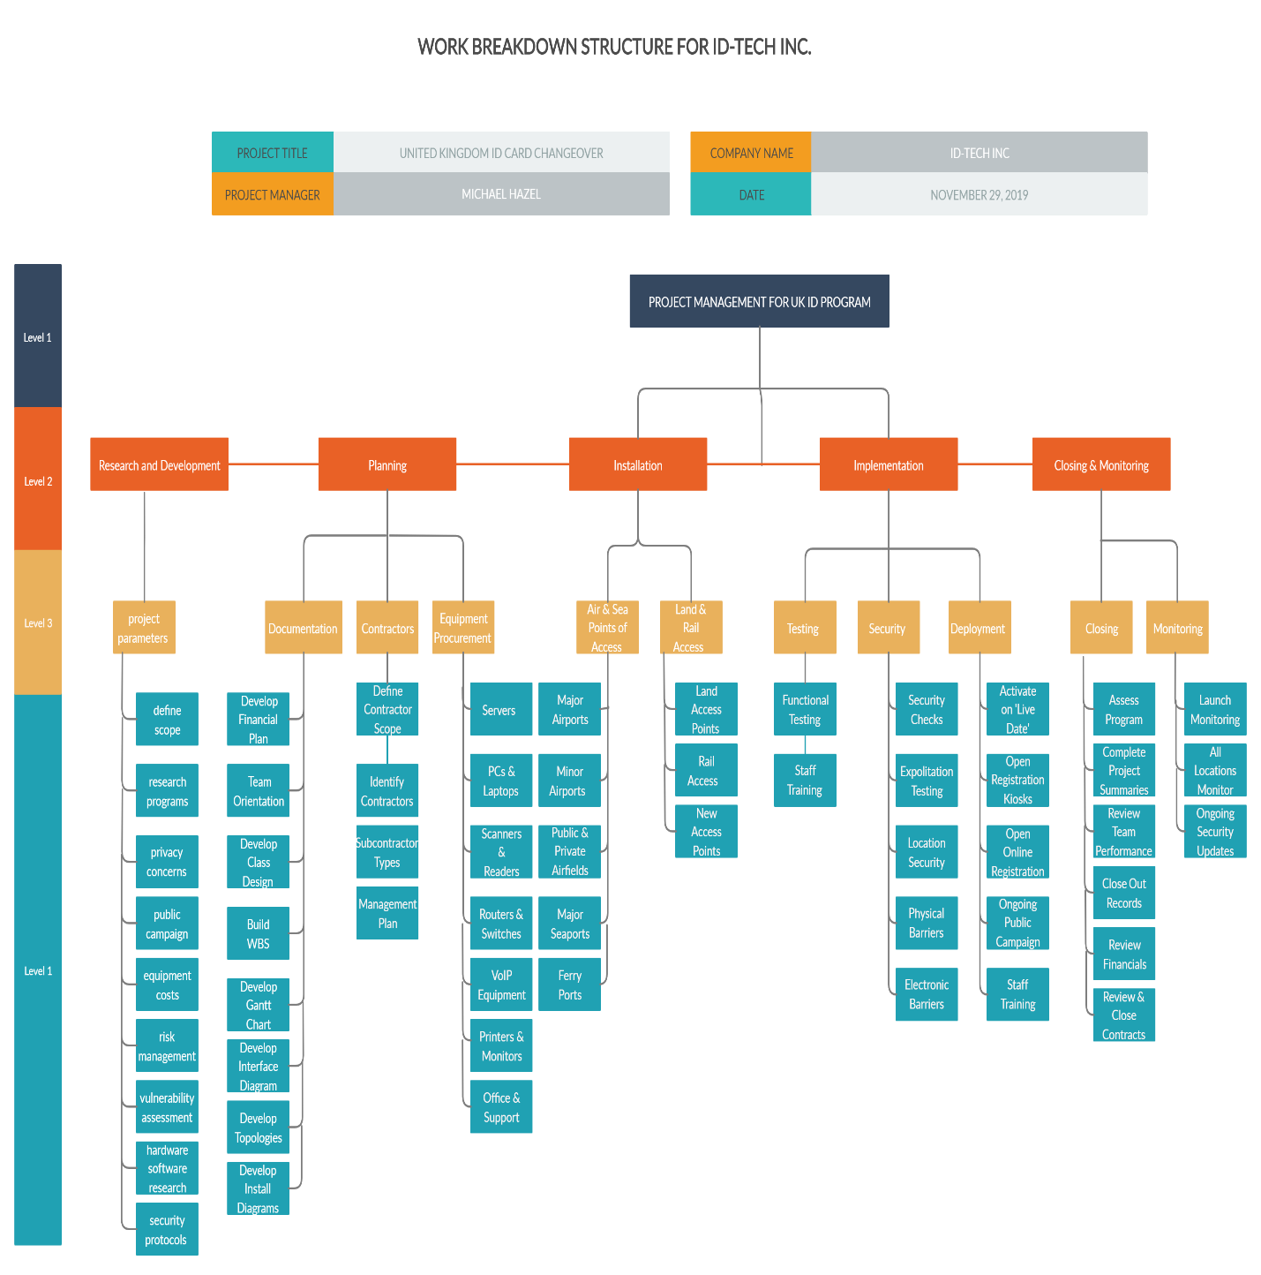

Work Breakdown Structure for UK ID Card Implementation Project



GANTT Chart (Tasks 1 - 21)



GANTT Chart (Tasks 22 - 39)



GANTT Chart (Tasks 39 - 60)



GANTT Chart (Tasks 54 - 69)

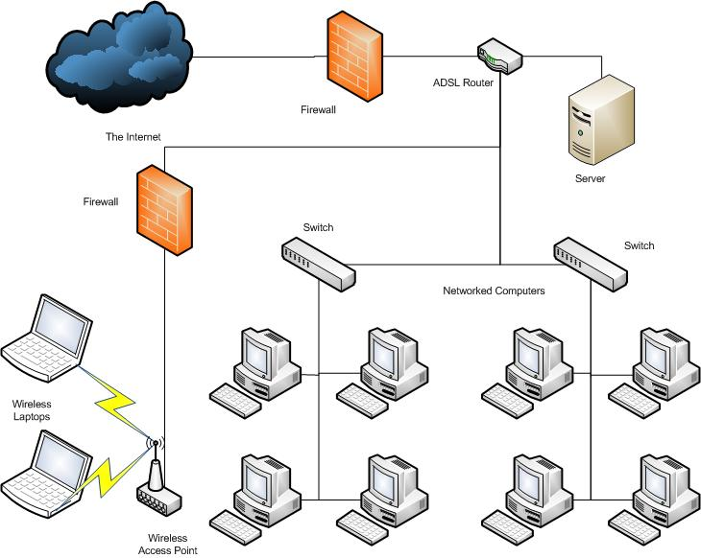

High Level Network Diagram

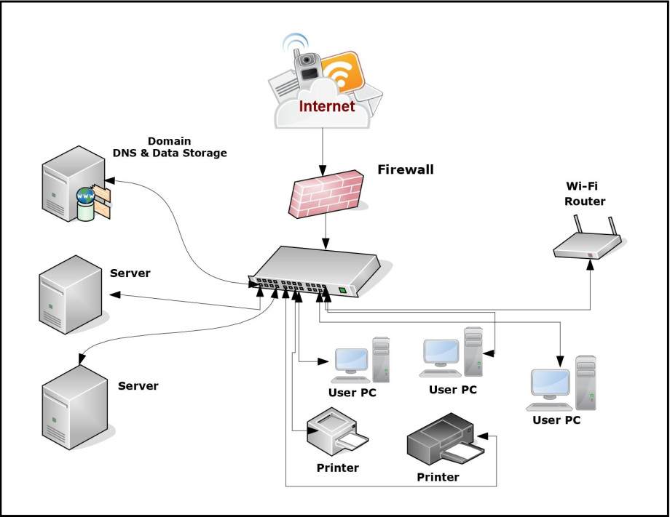

Network Connection Diagram

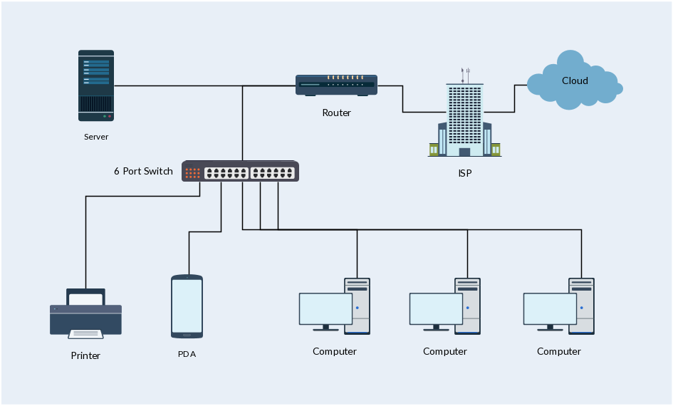

Switch and Router Connection Diagram



Network configuration between locations

Project References and Resources

A familiar sight at border control desks around the world. (2019, March 15). Retrieved from <https://www.gemalto.com/govt/document-readers/at9000-mk2>.

Benaston. (2019, September 9). 9 Of the Most Popular Project Management Methodologies Made Simple. Retrieved from <https://thedigitalprojectmanager.com/project-management-methodologies-made-simple/#project-management-methodologies-overviews>

Beynon-Davies, P. (2011, March 1). The UK National Identity Card. Retrieved from <https://hbsp.harvard.edu/download?url=/courses/635469/items/JIT027-PDF-ENG/content&metadata=e30=>

Gemalto MRZ Swipe Reader CR100. (2019, March 15). Retrieved from <https://www.gemalto.com/govt/document-readers/cr100>.

Inspiron Desktop & Monitor. (n.d.). Retrieved from <https://www.dell.com/en-us/cart>.

Muslihat, D. (2018, March 2). Agile Methodology: An Overview. Retrieved from <https://zenkit.com/en/blog/agile-methodology-an-overview/>

PowerEdge T330 Tower Server. (n.d.). Retrieved December 1, 2019, from <https://www.dell.com/en-us/work/cart>.

Segue. (2015, August 25). 8 Benefits of Agile Software Development. Retrieved from <https://www.seguetech.com/8-benefits-of-agile-software-development/>

Server & Switch. (n.d.). Retrieved December 1, 2019, from <https://www.dell.com/en-us/work/cart>.

Validation and Verification. (2017, July 17). Retrieved from <http://acqnotes.com/acqnote/careerfields/validation-and-verification>

Xerox WorkCentre 6027. (n.d.). Retrieved December 1, 2019, from <https://www.dell.com/en-us/work/buy?cs=04&~ck=mn>.